
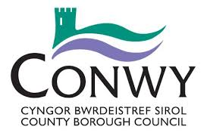

CONTRACT NUMBER | CONWY COUNTY BOROUG COUNCIL  COLLEGE TRANSPORT SERVICE  COLLEGE BUS  ABERGELE TO COLEG LLANDRILLO  RHOS-ON-SEA CAMPUS | OPERATOR
41B |  | ALPINE  TRAVEL | 01745  350 370

COLLEGE DAYS ONLY
 | AM |  | PM
 | Mon-Friday |  | Mon-Thurs. | Friday
ABERGELE | 08:30 | COLEG LLANDRILLO | 16:45 | 16:10
LLANDDULAS FAIR VIEW | 08:35 | LLANDDULAS FAIR VIEW | 17:00 | 16:25
COLEG LLANDRILLO | 08:50 | ABERGELE STOP B | 17:05 | 16:30

STUDENTS ARE ADVISED TO BE AT THE BUS STOP 5-10 MINUTES BEFORE THE BUS DEPARTS
THE BUS WILL OPERATE ON A NO PASS, NO TRAVEL BASIS – PASSES MUST BE PROVIDED FOR EVERY JOURNEY

